Digital Chip Design Program
RTL Design
Alia Alsultan
Elat Alkhalaf
Lana Aldhali
Manar Alnuqaydan

Task #06
8/07/2026

Combinational Datapath Design Part 2

Task #6.1

6.1.1

6.1.1.1

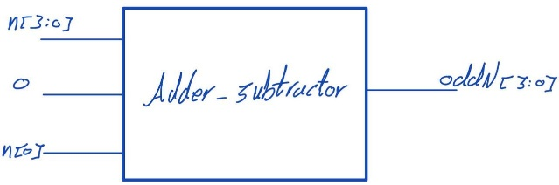

6.1.1.2

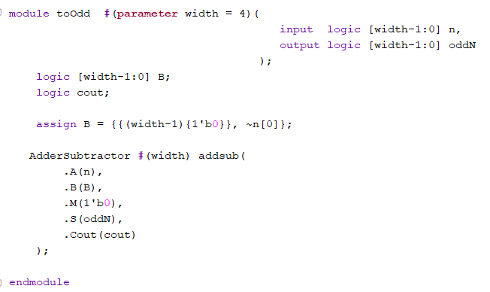

6.1.1.3

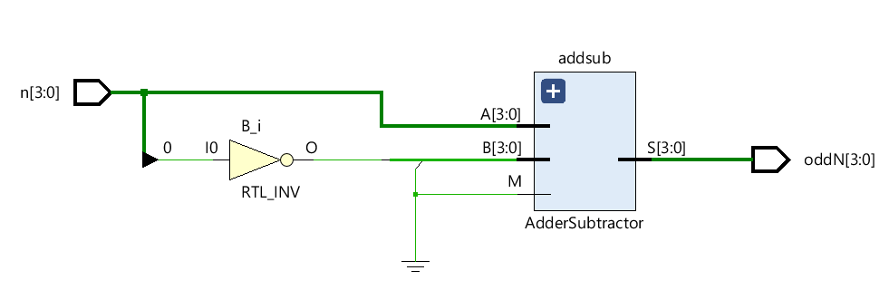

6.1.1.4

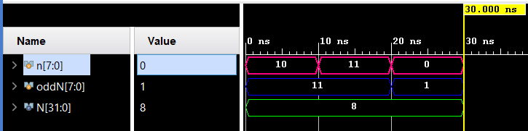

6.1.2

6.1.2.1

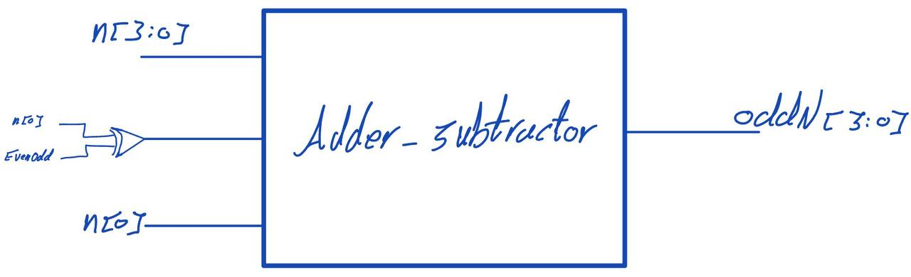

6.1.2.2

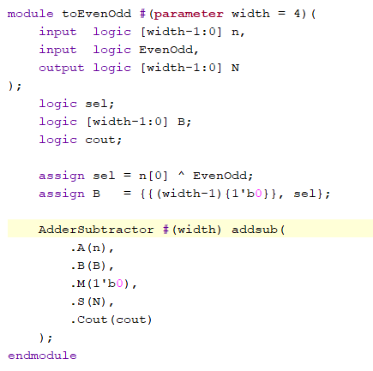

6.1.2.3

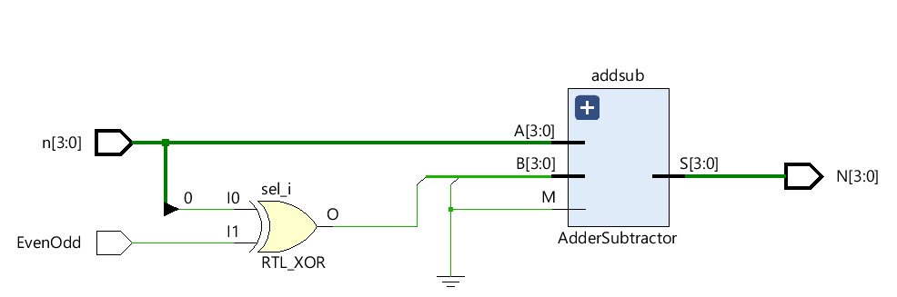

6.1.2.4

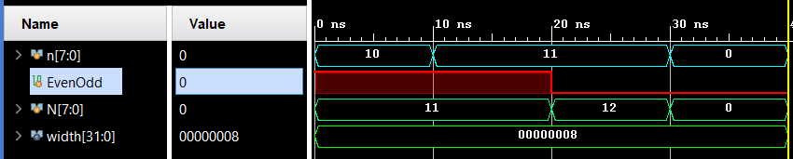

Task #6.2

6.2.1

6.2.1.1

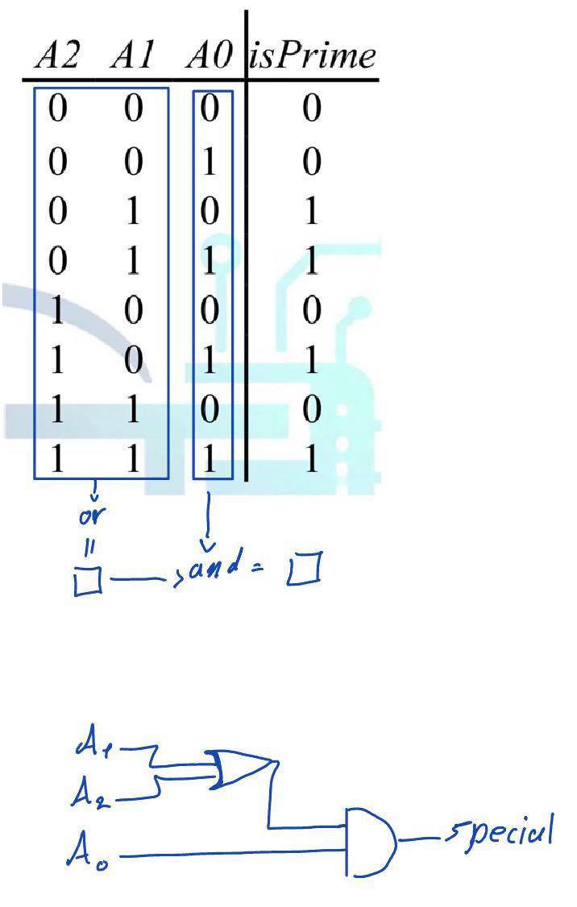

6.2.1.2

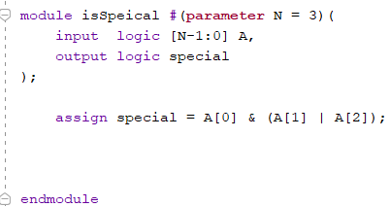

6.2.1.3

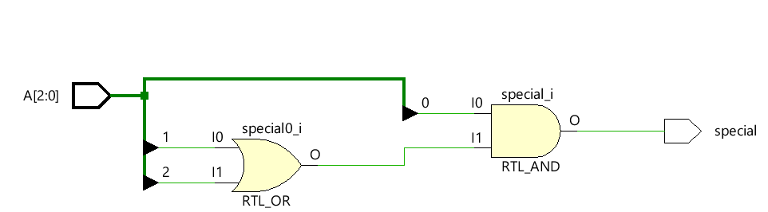

6.2.1.4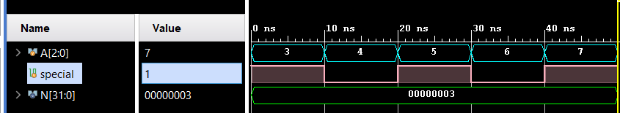

Task #6.3

6.3.1

6.3.1.1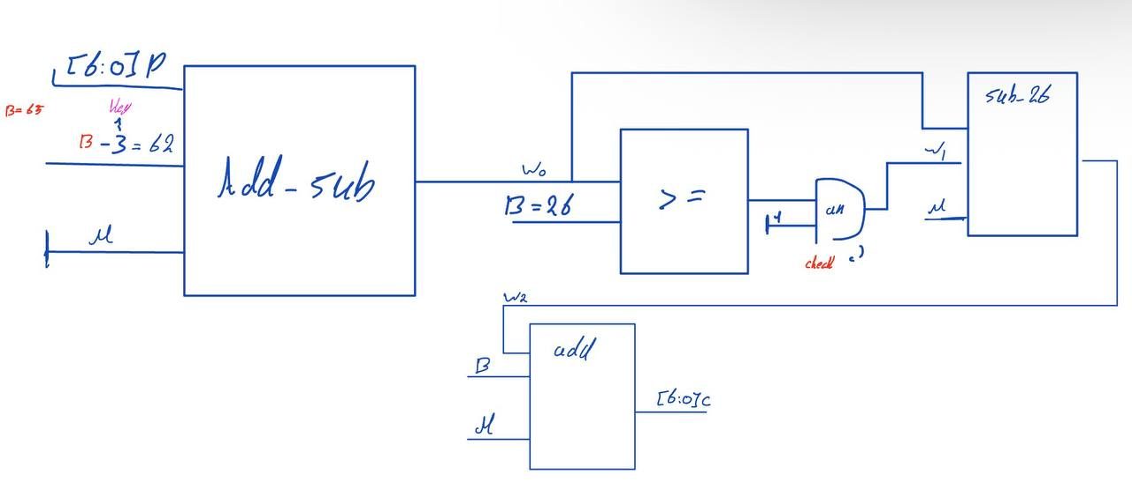

6.3.1.2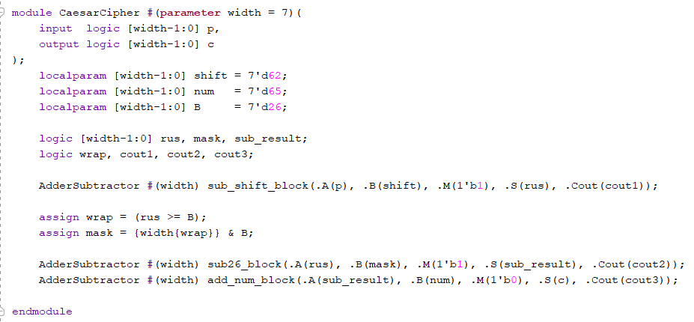

6.3.1.3

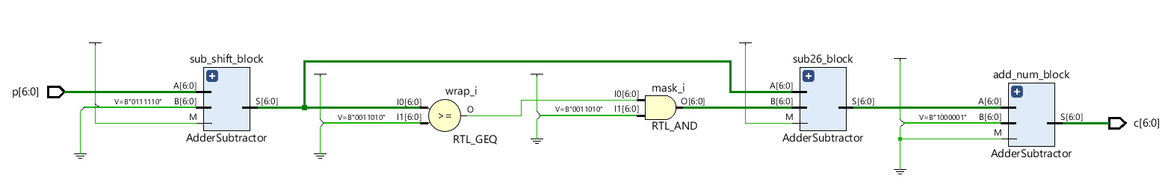

6.3.1.4

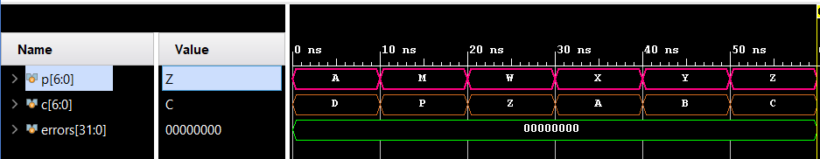

Work distribution

Section | Alia | Elaf | Lana | Manar
Report | ✔ | ✔ | ✔ | ✔
Task 6.1 | ✔ | ✔ | ✔ | ✔
Task 6.2 | ✔ | ✔ | ✔ | ✔
Task 6.3 | ✔ | ✔ | ✔ | ✔

